NAAN MUDHALVAN ASSIGNMENT

**NAME:**VIGNESHWARAN N

**DEPARTMENT:** COMPUTER SCIENCE AND ENGINEERING

**COLLEGE:** DHANALAKSHMI SRINIVASAN INSTITUTE OF TECHNOLOGY

**NAAN MUDHALVAN COURSE:** DIGITAL MARKETING

**NM ID:**D629A359EAFCAED8408416BED2069C27

**ASSINGMENT 1:**

Create a blog or website using blogspot and wordpress. Customize the theme design and post new article with 500 words

**URL:**<https://enemstudios.blogspot.com/2023/08/the-art-of-freezing-time.html?m=1>

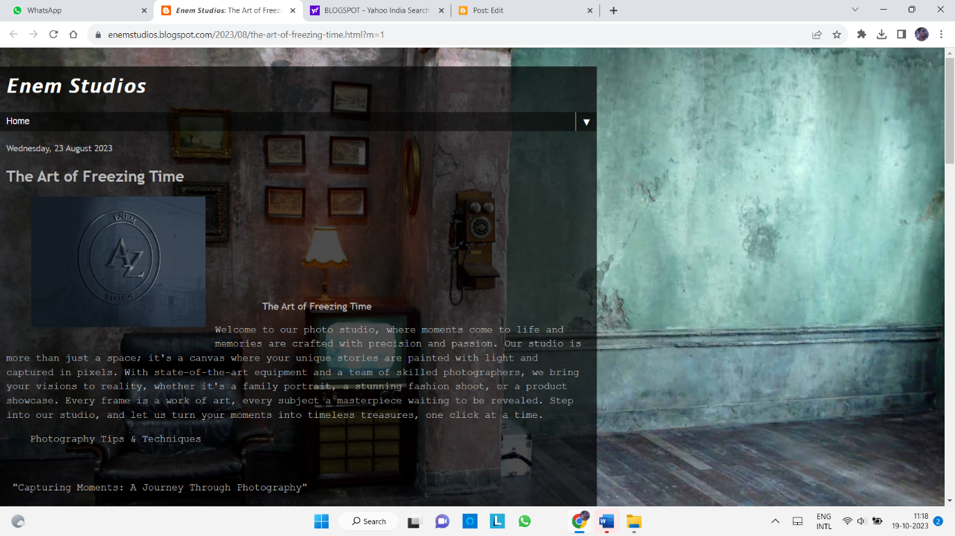

**ASSINGMENT 2:**

Create a new Facebook business page and post one social media poster for your brand.

**URL:**[**https://www.facebook.com/profile.php?id=61550573343750&sk=photos**](https://www.facebook.com/profile.php?id=61550573343750&sk=photos)

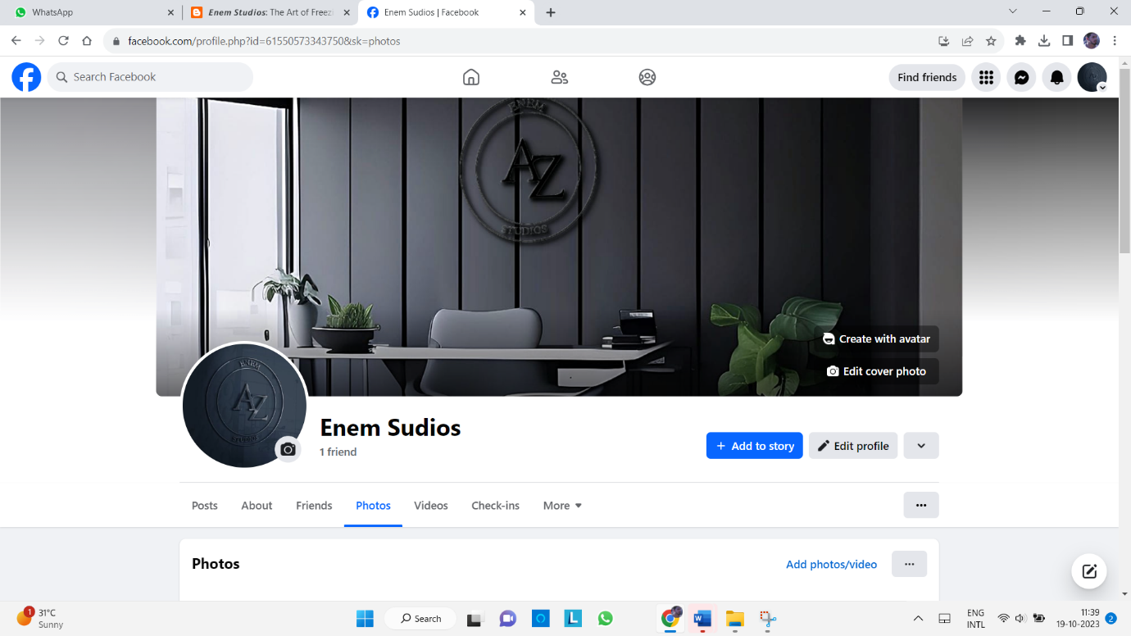

**ASSIGNMENT 3:**

Create and design a advertisement poster using canva.

**URL:** [**https://www.facebook.com/photo.php?fbid=122132487590019111&set=pb.61550573343750.-2207520000&type=3**](https://www.facebook.com/photo.php?fbid=122132487590019111&set=pb.61550573343750.-2207520000&type=3)

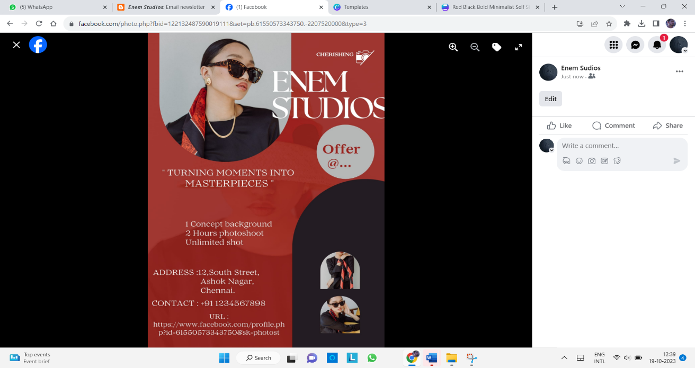

**ASSIGNMENT 4:**

Create an Email newsletter design using Mailchimp or Canva tool

**URL:**[**https://enemstudios.blogspot.com/2023/09/email-newsletter.html?m=1**](https://enemstudios.blogspot.com/2023/09/email-newsletter.html?m=1)

